BECE206P Analog Circuits Lab Experiment 1

Name: Nikhil Rout

Reg. No.: 22BEC1020

Frequency Response of CE amplifier (Simulation)

# AIM: To design and verify the Frequency Response of CE amplifier

# SOFTWARE REQUIRED: LTspice

# PROCEDURE:

1. Open a new LTspice schematic and create a single stage Common Emitter Amplifier circuit as provided
2. Set the input signal amplitude to 10mV
3. 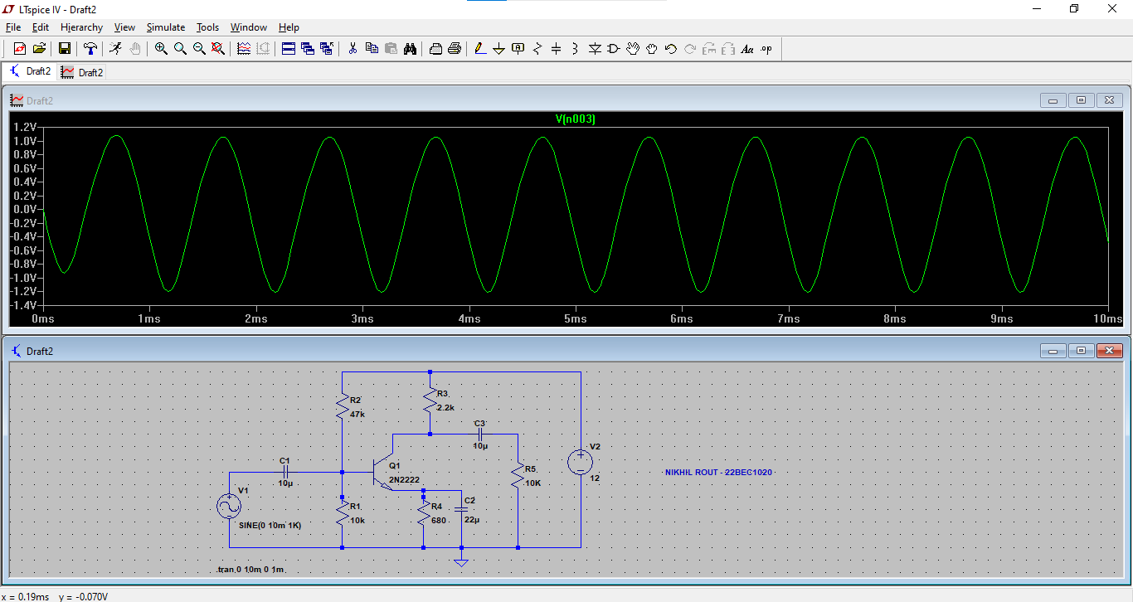Edit simulation command to Transient Analysis and begin simulation
4. Edit simulation command to DC operating point and begin simulation

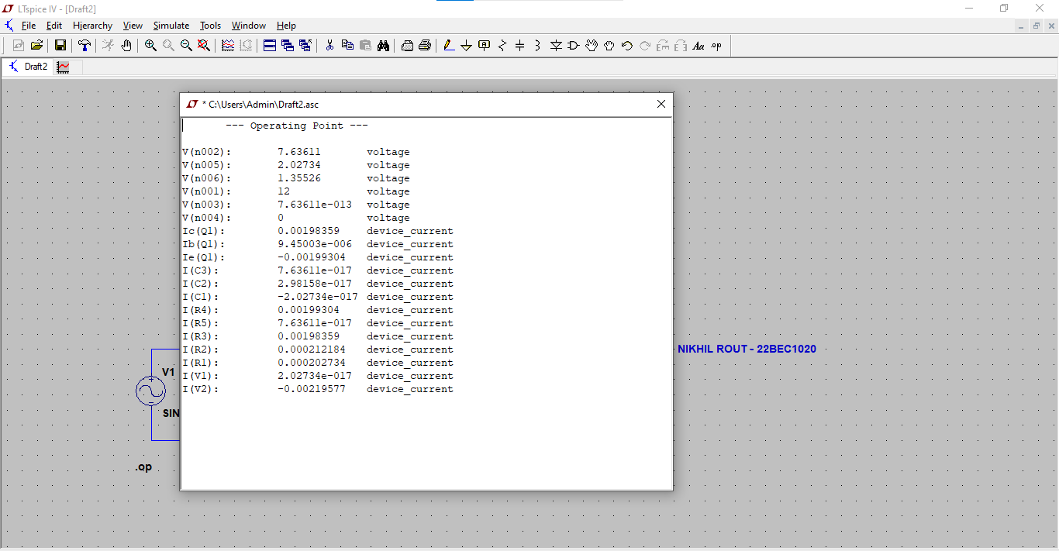

1. Edit input signal by setting small signal AC analysis AC amplitude to 1 and AC phase to 0
2. Edit simulation command to AC analysis and begin simulation

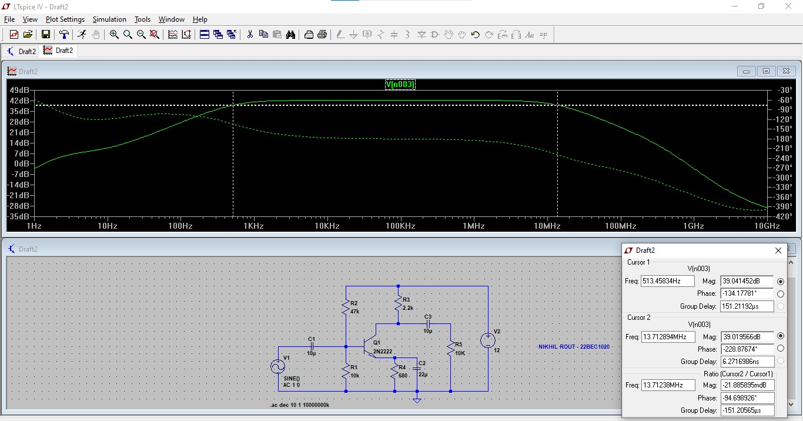

1. Select cursors on the plotted amplified output response and move such that the cursors’ magnitude is 3dB less than the maximum magnitude of the output response.
2. Determine bandwidth by subtracting the lowest frequency from the highest frequency
3. Create a Multistage Common Emitter Amplifier and repeat the complete process for

* Transient analysis:

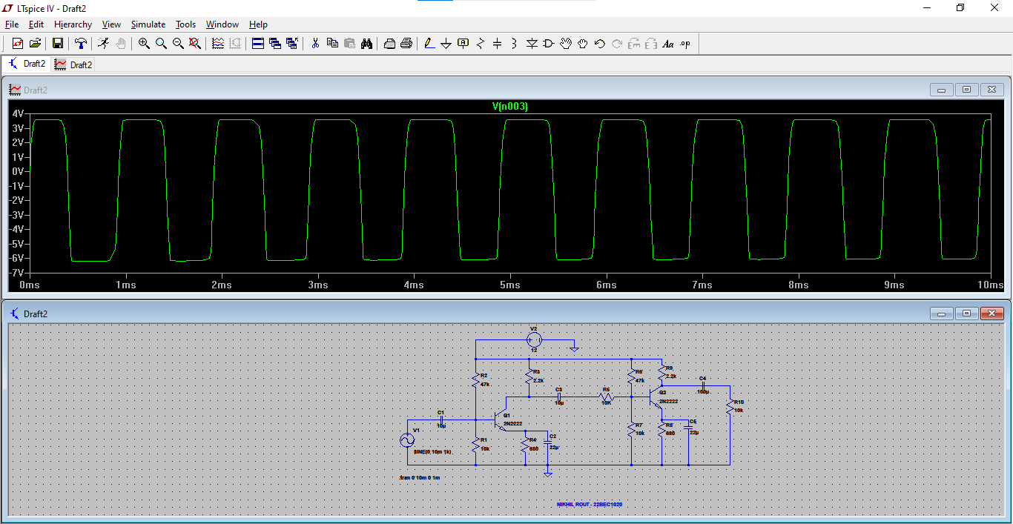

* DC Operating Point:

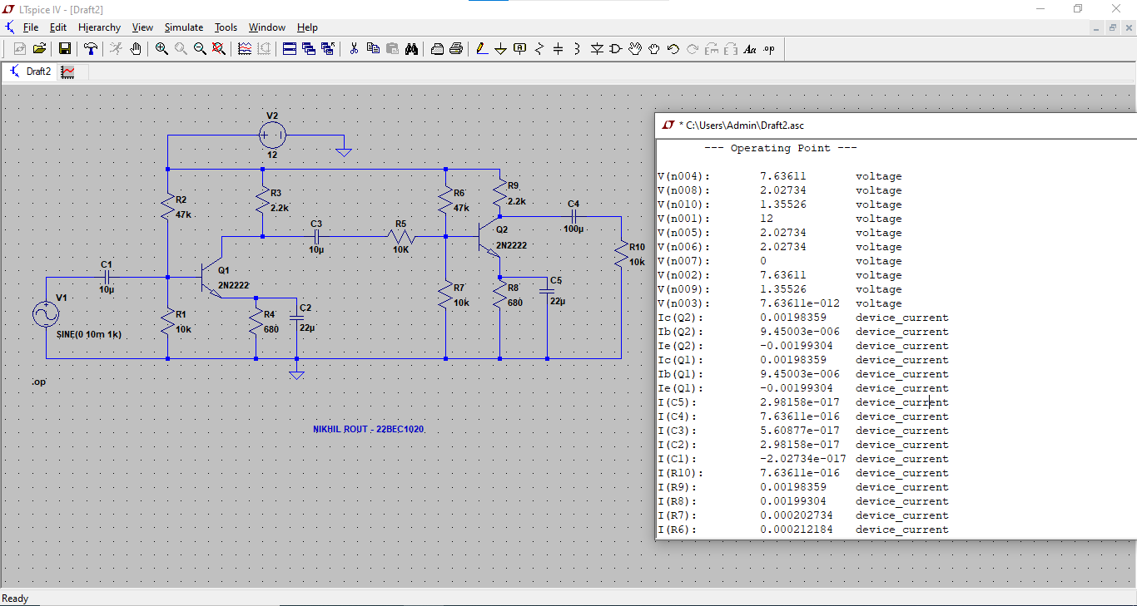

* AC analysis:

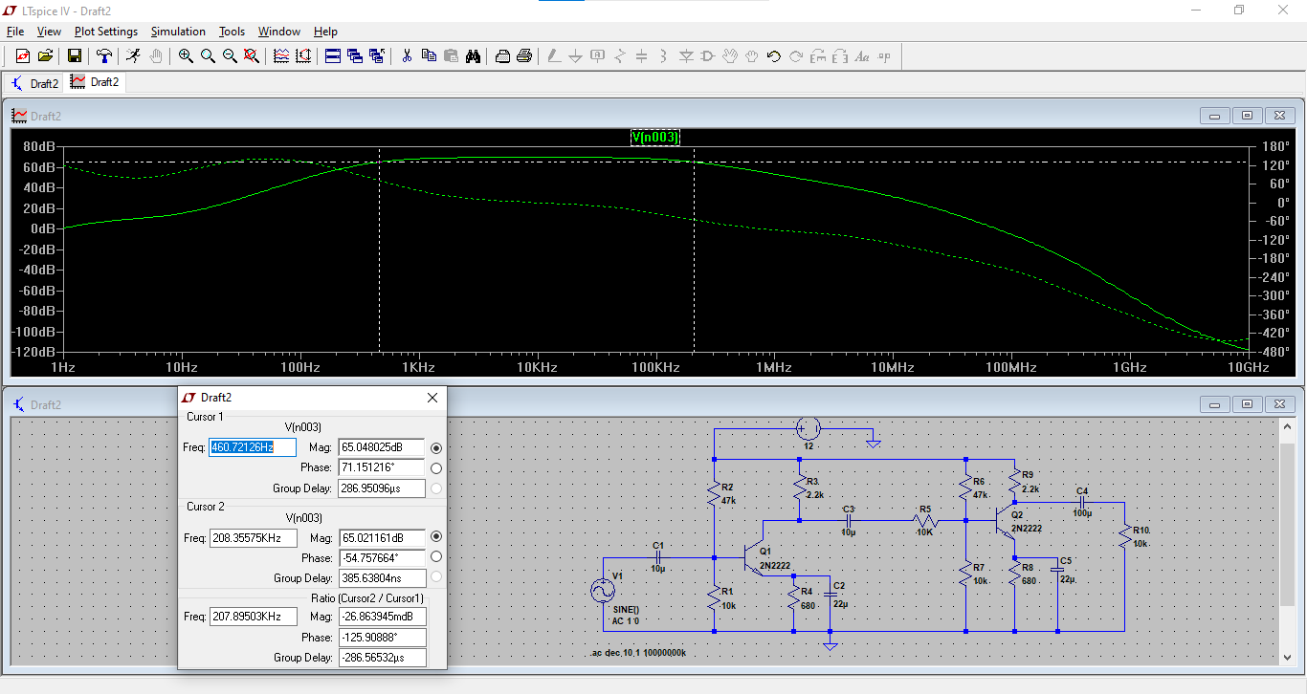

**OBSERVATION:**

**SINGLE STAGE AMPLIFIER:**

Transient analysis –

DC Operating Point

AC Analysis –

**MULTI-STAGE AMPLIFIER:**

Transient analysis –

DC Operating Point

AC Analysis –

**INFERENCES:**